Essential Information

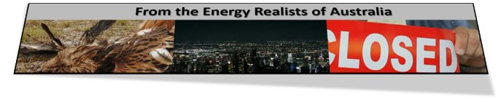

Two five-minute videos

Mark Mills explains why the green energy transition is not happening.
https://www.youtube.com/watch?v=wDOI-uLvTnY

The limit of wind and solar power
https://www.youtube.com/embed/RqppRC37OgI

On wind droughts and lack of storage
https://spectator.com.au/2022/07/energy-policy-where-parallel-universes-are-set-to-collide/

Key points. When the next coal power station closes, every wind drought will threaten the power supply and prolonged wind droughts will be potentially catastrophic.
If the coal capacity is not maintained, then more gas will have to be burned at a crippling cost.
Potentially fatal neglect of wind droughts.
https://www.spectator.com.au/2022/11/the-voice-of-energy-realism/

The environmental dark side of intermittent providers. Bill Stinson’s survey of the worldwide environmental footprint from mining to disposal of junk and toxic waste,
https://www.flickerpower.com/images/Environment-Destruction-The-Dark-Side-of-Renewable-Energy-1.pdf
SHORT FILMS
Upper Burdekin https://vimeo.com/706882264
Kaban https://vimeo.com/633451905
Chalumbin https://vimeo.com/582415839

Wind and solar are not cheap when you count the cost of firming.

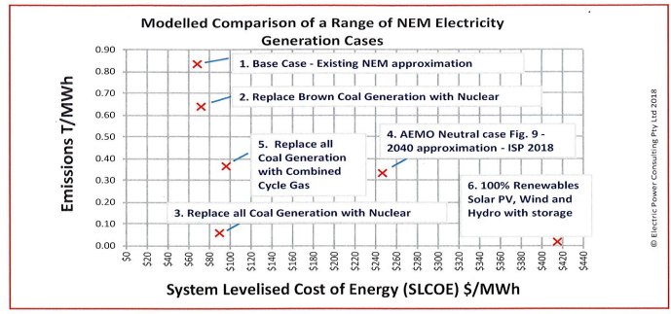

The source is a paper cited in this post which explains how intermittent and unreliable providers drive reliable power out of the grid.

https://newcatallaxy.blog/2021/09/25/the-real-cost-of-unreliable-energy/
Think about nuclear power. https://youtu.be/9Oottmvak7c
WEBSITES
These are the briefing notes that the ERA team has been sending to all the state and federal members and a large list of journalists since early 2020.

https://www.riteon.org.au/netzero-casualties/

https://www.flickerpower.com/index.php

