**WHY WIND AND SOLAR CAN’T REPLACE COAL IN AUSTRALIA**

Spoiler: Its all about the wind droughts. Especially at night.

**Three critical features of the power supply and what that mean**s.

1. Input to the grid must continuously match the demand
2. The continuity of RE is broken on nights with little or no wind.
3. There is no large-scale storage to bridge the gaps.

**Conclusion. The transition to wind and solar power can’t proceed with current storage technology.**

**Wind droughts happen**.

Many people assume that the wind is always blowing somewhere but there are periods of very little wind power, approaching zero, across the whole of the NEM for periods up to 4 days.

**BECOME WIND LITERATE** SEE **THE NEMWATCH WIDGET**

https://www.nem-watch.info/widgets/reneweconomy/

**Late afternoon on 23 July 2020, wind meeting 2% of demand in the NEM** (163MW)

Sometimes there are several severe wind droughts in quick succession. June 2020 was the worst in recent times, before that June 2017 had a 74 hour period of drought

with several shorter episodes.

The most serious episode in very recent memory was a spell of 40 hours in August 2022.

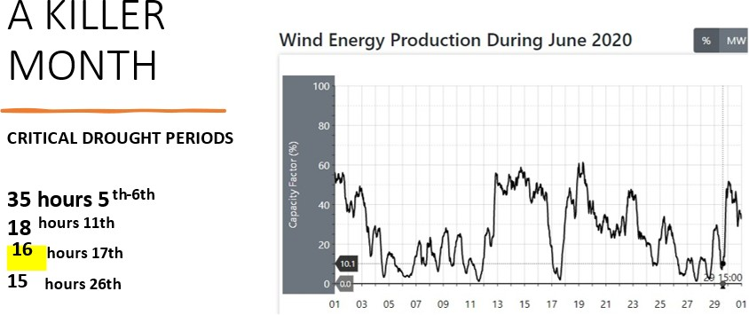

**THE TIPPING POINT**

Over the last 20 years coal capacity ran down as plants closed and were not replaced.

Now Liddell is gone and the (simplified) chart below shows how the capacity of conventional power (mostly coal) has reached the level of demand. **When more capacity is lost, a gap will open up between capacity and demand.**

The expectation is that RE will make up the difference because RE contributed 36% of the power supply last month.

**36% penetration of solar and wind power looks good but on windless nights there is no wind and solar power. Installing more capacity does not help.**

